Validation of AI Coding for Ad Classification
This study adopts a cross-sectional design to evaluate whether artificial intelligence (AI) can accurately label online food and alcohol advertisements compared to human judgment. The primary objective is to assess the level of agreement between AI-generated labels (using OpenAI’s GPT-4o model) and human coders’ classifications, while also examining whether individual characteristics (e.g., demographics, nutrition knowledge, and social media habits) influence ad classification. To accomplish this, 3000 ads from Meta platforms (Facebook, Instagram, Snapchat) were automatically labelled by GPT-4o and then independently classified by human coders recruited via Amazon Mechanical Turk.
Contents
Introduction 1
Ads Data Preparation 2
Human Coding Procedure 3
Target Population and Recruitment 3
Ad Classification Survey 3
Main Classification Task 4
Social Media and Nutrition 4
AI Classification Process 5
Model Description 5
Technical Implementation 5
Data Analysis 6
Validation Metrics 6
Other Analyses 6
Conclusion 7
Appendix 7

Introduction
This study examines whether artificial intelligence (AI) can accurately label online food and alcohol ads in a way that matches human judgement. With the rapid growth of online advertising, it is becoming increasingly important to have reliable methods to classify ads. Traditionally, human coders have done this task, but using AI could make the process faster and more consistent. Our aim is to evaluate whether AI can successfully replicate or even improve human classifications. As AI continues to advance, its capabilities may help government agencies better monitor advertising practices and protect public health.
We start with a collection of 3000 online ads from the Meta platforms (Facebook, Instagram, Snapchat) that feature both images and text. Using OpenAI’s GPT-4o model, we automatically label each ad based on its content (premium offers, marketing strategies, food categories, etc.). To validate these AI labels, human coders recruited through Amazon Mechanical Turk (MTurk) are asked to classify the same sample of ads. By labelling the same ad multiple times by different human coders, we incorporate diverse human perspectives, which minimizes individual bias and strengthens the reliability of the findings. After classifying the ads, the participants answer four brief demographic questions covering their age, gender, education and language preference, and seven additional questions regarding their self-reported health, daily social media use, preferred social media platforms, self-rated nutrition knowledge and whether they have seen unhealthy ads in various contexts over the past 30 days.
Our key research questions include:
1. How accurately does the AI [GPT-4o] label online ads compared to human coders?
2.What is the level of agreement between different human coders, and between human coders and the AI system?
3. Do personal factors – such as demographics or nutrition knowledge – affect how individuals classify online ads?
To answer these questions, we will compare the AI-generated labels with the human-coded labels using statistical measures like accuracy and Cohen’s Kappa, which shows the level of agreement beyond chance. We will also explore how individual differences, such as age or social media habits, influence ad classification.
This research is important both scientifically and socially. Scientifically, it can help us understand how well AI interprets visual and textual content in online ads compared to human insight. Also, our research will add to the growing body of knowledge on AI’s capabilities in automated content analysis, further clarifying its potential applications. On a societal level, more reliable AI labelling of ads could lead to improved consumer protection and encourage more responsible advertising practices. For example, if AI can reliably identify unhealthy or misleading ads, it could help local governments and advertisers improve the standards of online advertising. Overall, our study aims to contribute to more effective, efficient and ethical practices in digital advertising.

Ads Data Preparation
The first step of the data collection involved a selection of Belgium brands, covering various food areas, such as: fast-food restaurants, alcohol brands, supermarkets, food delivery companies, and brands of specific food products like snacks, dairy, confectionery, drinks, etc. The final list contained 132 Belgian brands and can be found in the excel file “Belgium brands.xlsx”. For these 132 brands, their Facebook Page ID was found manually, as this is the main reference point to retrieving advertisement data from the Meta Ad Library.
The next step represents the retrieval of ads data from the Meta Ad Library using the AdDownloader package for both ad metadata as well as ad images. For a period of one year – from July 2023 until July 2024 – we downloaded 50772 ads and their metadata (ad delivery dates, ad text, page name, ad reach, etc.). Since we noticed a lot of overlap between ads of the same brands (multiple ads with the same picture and text), and since we would like the validation sample to be as varied as possible, we first downloaded the media content of the ads (both images and videos) and then randomly sampled a set of images for the validation. We converted the ad videos to images, by taking a frame every 2 seconds for each video and saved them in the same folder as the images. Then, we deduplicated the resulting set of images by using k-means clustering (add ref) and randomly selected 3000 unique images.
The final data contained a sample of 3000 ad images, spanning over 2875 ads and covering 79 brands, including the metadata for the selected ads. Out of these 2875 ads, 55 did not contain a caption, in which case it was replaced with a default “No ad text available” tag. The first ad in the sample was launched on June 27th, 2023, and the last ad finished its campaign on July 9th, 2024.

Human Coding Procedure
Target Population and Recruitment
Human coders were recruited from the general adult populations of the Netherlands, Belgium, and France. Inclusion criteria required participants to be at least 18 years old, reside in one of these countries, and be proficient in Dutch, French, or English. Basic digital skills were necessary to complete the online survey, but no specialized expertise in nutrition or health was required. The study targeted a total of 3,000 participants, ensuring that each advertisement was classified by five different human coders. This redundancy aimed to minimize individual bias and increase the reliability of the human-coded labels.
Recruitment was conducted via Amazon Mechanical Turk (MTurk), a widely used online crowdsourcing platform. After providing informed consent, participants were directed to a Qualtrics-hosted survey. Initially, participants were identified by their MTurk IDs, which served to ensure that each participant viewed each ad only once. For privacy protection, these IDs were replaced with pseudonymous codes immediately after data collection. No other personally identifying information was collected, and all survey data were stored in a de-identified manner for subsequent analysis.

Ad Classification Survey
The survey, hosted on Qualtrics, was divided into several sections, and was designed to take around 20 minutes. The first section collected demographic information, including age, gender, education, and language preference. This was followed by the ad classification task, and finally, additional questions regarding nutrition knowledge, health status, social media usage, and recent exposure to unhealthy food advertisements. A summary of the different sections and their respective questions can be found in Table 1 in the Appendix.
All participants received the same compensation regardless their responses, via MTurk’s payment system, calculated based on an estimated hourly rate of $10 for a 20-minute survey. However, the survey included 3 random attention checks to ensure data quality, and if a participant failed more than one of these checks, their response was rejected (because they were not paying attention and picked answers randomly) and compensation not paid.

Main Classification Task
The core of the survey focused on the classification task, where participants were asked to evaluate five distinct advertisements sequentially. For each ad, they viewed the ad image, accompanying text, and the brand running the ad (see Figure 1 in the Appendix), and they answered a series of structured questions designed to capture key aspects of the advertisement’s content and presentation (see Figure 2 in the Appendix). The questions covered multiple dimensions, including product type, marketing techniques, and target audience, as well as more nuanced elements like the presence of premium offers and the level of food processing. An overview of these classification questions is provided in Table 1 in the Appendix.
To ensure consistency and accuracy in responses, participants were provided with an instructions document that outlined definitions, examples, and guidelines for each question of the classification task. A link to this document was prominently displayed at the beginning of the survey, encouraging participants to review it before starting. Additionally, before the classification of each individual advertisement, another link to the instructions was provided, allowing participants to revisit the guidelines as needed. To further ensure engagement with the instructional material, the survey tracked whether participants had accessed the instructions within the first three ads. If no instruction link had been clicked during this phase, a prompt appeared reminding them to review the document to ensure correct and consistent answers.
Participants first identified whether the ad contained alcoholic beverages and/or other non-alcoholic products. They then classified the ad type – distinguishing between manufacturers, retailers, and restaurants/takeaways (with/without a product) – and selected the intended target audience (children, adolescents, or adults). Further, they were asked to detect any premium offers (such as discounts, contests, or loyalty programs) and marketing strategies (e.g., use of celebrities, licensed characters, or special events) present in the ad.
The survey also required participants to classify the food categories featured in each ad based on WHO guidelines. For each selected food category, they had to then determine the level of food processing (e.g., unprocessed, processed, ultra-processed).
To maintain data quality, three randomized attention-check questions were embedded within the classification tasks (add ref). These checks were designed to identify inattentive respondents and maintain the integrity of the classification dataset.

Social Media and Nutrition
Following the ad classification tasks, participants completed a set of questions focused on their social media usage, self-perceived health, and nutrition knowledge. These questions were included to explore potential relationships between participant characteristics and their ad classification decisions.
First, participants reported how many hours per day they spent on social media and selected the platforms they used most frequently (e.g., Facebook, Instagram, Snapchat). Then, they rated their self-reported health nutrition knowledge, on a Likert scale. They also answered questions about their recent exposure to unhealthy food ads, indicating where they had seen such advertisements (e.g., TV, social media, billboards) and how often they encountered them over the past 30 days. Additionally, they identified promotional techniques commonly used in unhealthy food advertising, such as celebrity endorsements or limited-time offers.

AI Classification Process

Model Description
The AI model employed in this study is OpenAI’s GPT-4o, a state-of-the-art language model with multimodal capabilities. GPT-4o is particularly well-suited for our application as it can process and interpret both textual and visual information, a critical feature when analysing online advertisements that incorporate images and accompanying text. Its robust natural language understanding enables it to interpret complex instructions and respond in a structured, consistent format. Furthermore, the model’s advanced reasoning abilities allow it to provide detailed explanations for each classification decision, thereby making its outputs directly comparable to human-coded data. Its capacity to analyse visual content, such as identifying specific elements in an advertisement, ensures that subtle contextual nuances are not overlooked (https://openai.com/index/hello-gpt-4o/). How does the AI handle other languages than English?
Technical Implementation
The AI classification is implemented in Python using the OpenAI API (specifically GPT-4o). GPT-4o is instructed to answer most classification questions in a binary (yes/no) format, with each response accompanied by a brief explanation. This ensures that the rationale behind each decision is captured for subsequent analysis.
Before beginning the ad classification, GPT-4o is provided with detailed instructions. For example, the instructions prompt outlines that the AI will be presented with an ad’s image, corresponding text (which may be in English, French, or Dutch), and the name of the company running the ad. This way, both the human coders and the AI have the same information at hand when labelling the advertisements.
The instructions further include definitions for key concepts (e.g., distinctions among food manufacturers, retailers, and restaurants, and definitions for various levels of food processing). GPT-4o is required to answer the questions using a strict format: *QUESTION_LABEL*: Yes/No – Brief explanation. This structured approach ensures consistency and comparability with human-coded responses and aims to ease the future parsing of the output.
The prompting was designed to simulate the guidelines provided to human coders, while presenting the possible answer choices as a list of distinct questions. For example, for premium offers, the prompt provides a series of tuples – each consisting of a question label (e.g., “GAMES”, “CONTESTS”, “2FOR3”, etc.) and a description of the type of premium offer (Are there offers that incentivize consumers to download mobile games or apps, often tied to promotions or rewards? e.g., ‘download the McDonald's app to receive a free hamburger’). The AI then responds for each category using the standardized yes/no format.
GPT-4o was presented with the same classification questions as the human participants (see section Ad Classification (per ad) in Table 1 in the Appendix), by following the same distinct yes/no question list format. However, if the answer is “Yes” for any of the 23 WHO food categories, the AI is immediately instructed to provide a follow-up line indicating the level of processing using the format: *<CATEGORY_LABEL>_PROCESSING*: <Processing Level> – Brief explanation.
ADD HERE EXAMPLE PROMPT

Data Analysis
The data analysis framework is designed to rigorously evaluate the performance of the AI model relative to human-coded labels and to uncover systematic patterns in any observed discrepancies. A critical decision involves defining the appropriate baseline for comparison. Rather than treating GPT-4o as the default standard or comparing it to individual coders, the study adopts a consensus-based approach among human coders as the baseline. For each ad, five independent human coders provided classifications, and a majority consensus was used to establish the final label for validation purposes. This method minimizes the impact of individual biases and offers a more reliable point of reference against which the AI’s outputs are compared.
When discrepancies occur among human coders (e.g., a tie in responses or diverse answers without a clear majority), additional rules are applied, such as defaulting to the most frequently selected option across the dataset or excluding ambiguous cases from certain analyses. By grounding validation in human consensus rather than a single source, the study ensures a fairer and more representative evaluation of the AI’s performance.
Using a combination of validation metrics and additional analytical techniques, we aim to assess both overall accuracy and the nuanced differences between AI predictions and human interpretations. These methods are described in more detail in the next two subsections.

Validation Metrics
A confusion matrix is generated for each category that accepted only one coding per ad, i.e., Ad Type or Targeting Group. The confusion matrix provides a granular view of GPT-4o’s predictions versus the human-coded values, which allowed for easy identification of the most commonly misclassified categories. Overall accuracy is then computed, using the confusion matrices created for the above-mentioned categories, as the proportion of correct AI predictions relative to the total number of advertisements. This metric provides an intuitive, summary measure of the AI’s success rate across categories.
To measure agreement while accounting for chance, Cohen’s Kappa is calculated for the other categories, where multiple options can be selected, i.e., for Premium Offers, Marketing Strategies, WHO Categories, etc. A high Kappa value would indicate strong alignment between the AI’s predictions and the manual labels, while a lower value would suggest discrepancies. Additionally, inter-rater reliability among the human coders will be further assessed using Fleiss’ Kappa, providing a robust measure of consistency across the five independent evaluations for each advertisement.

Other Analyses
To gain further insights into the specific misclassifications, a discrepancy analysis is conducted. For each instance where GPT-4o and human coders disagreed, the predicted and actual labels were logged and grouped by frequency. This approach highlighted patterns in the AI’s misclassifications, such as common confusions between similar ad types or processing levels. For example, GPT-4o might confuse “Restaurant with product” and “Supermarket with product”, which provided actionable insights for refining the prompting of the AI.
Finally, regression analyses (or ANOVA) are employed to examine whether demographic variables – such as age, gender, education level – and self-reported nutrition knowledge predict classification discrepancies. These analyses will help identify systematic patterns in the differences between AI and human coding, shedding light on whether certain participant characteristics influence the interpretation of ad content and contribute to variations in labelling outcomes.

Conclusion
This validation process provided a rigorous assessment of GPT-4o model’s classification performance. The combination of accuracy, Kappa scores, and misclassification analysis facilitated a comprehensive understanding of the AI's strengths and limitations. This approach is designed to ensure reliable deployment of AI in automated advertisement classification, with an emphasis on continual improvement through iterative validation and model refinement.

Appendix
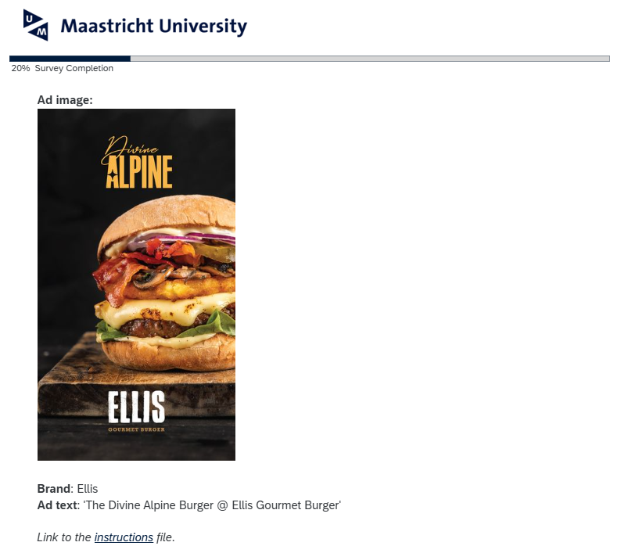
Figure 1 – Example ad for classification, including the image and text of the ad, and the brand running the campaign.
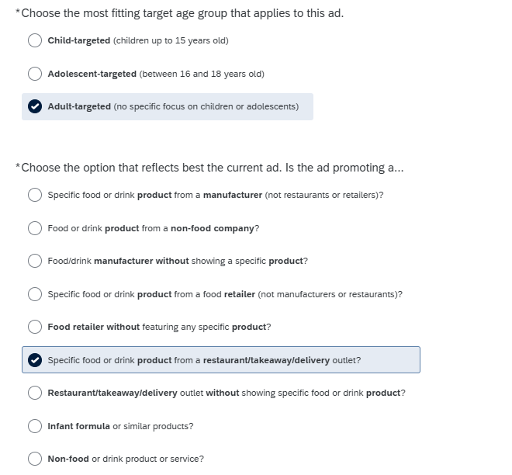
Figure 2 - Example questions for the ad classification (target age group and type of ad).
Section | Question | Response format
Demographic Information | Age, Gender, Education Level, Language Preference | Single choice
Ad Classification (per ad)
- Alcohol Presence | Is there alcohol in the ad? | Yes/No/Not Sure
- Non-alcoholic Products | Are there other non-alcoholic products in the ad? | Yes/No/Not Sure
- Ad Type | What type of ad is this? (e.g., Manufacturer, Retailer, Restaurant) | Single choice
- Target Audience | Who is the target audience? (Child, Adolescent, Adult) | Single choice
- Premium Offers | Identify premium offers (e.g., Discounts, Gifts, Contests) | Multiple choice + ‘Other’ option
- Marketing Strategies | Identify marketing strategies (e.g., Celebrities, Characters) | Multiple choice + ‘Other’ option
- WHO NPM Food Categories | Identify food categories present (e.g., Snacks, Dairy, Drinks) | Multiple choice + ‘Other’ option
- NOVA Food Processing Level | Determine processing level of identified foods (e.g., Ultra-Processed) | Single choice, for each category selected in the WHO Food Categories question
Attention Checks | Three randomly placed attention check questions | Single choice
Social Media and Nutrition
- Self-reported Health | How would you describe your health? | Likert Scale (Very Good – Very Bad)
- Social Media Usage | How many hours per day on social media? | Single choice (range)
- Preferred Platforms | Which social media platforms are used most frequently? | Multiple choice + ‘Other’ option
- Nutrition Knowledge | How would you rate your nutrition knowledge | Likert Scale (Not at all – Extremely Knowledgeable)
- Ad Exposure | Where have you seen unhealthy ads in the last 30 days? | Multiple choice
- Ad Frequency | Frequency of seeing specific food ads (e.g., sugary drinks) | Likert Scale (Never – More than once a day)
- Promotional Techniques | Types of promotions seen in unhealthy ads (e.g., | Multiple choice
Table 1 – Summary of the Ad classification survey questions.

